* **QUESTION 1**

#include<stdio.h>

#include<conio.h>

int main()

{

int i,n;

printf("Enter a number to print its table");

scanf("%d",&n);

for(i=1;i<=10;i++)

{ printf("\n");

printf("%d*%d=%d",n,i,(n*i));

}

getch();

}

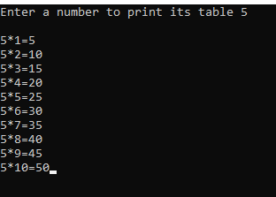

**QUESTION 2**

#include<stdio.h>

#include<conio.h>

int main()

{

int i;

float avg=0,sum=0,a;

printf("Enter Number:");

for(i=1;i<=10;i++)

{

printf("\n %d:",i);

scanf("%f",&a);

sum+=a;

}

printf("Average: %f",sum/10);

getch();

}

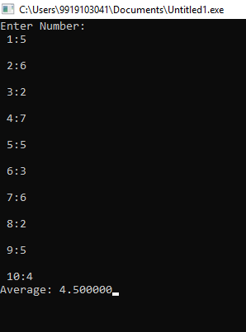

**QUESTION 3**

#include<stdio.h>

#include<conio.h>

int main()

{

printf("Enter a number to print its factorial\n");

int i,n,f=1;

scanf("%d",&n);

for(i=n;i>=1;i--)

{

f=f*i;

}

printf("Factorial:%d\n",f);

getch();

}

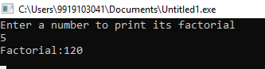

**QUESTION 4**

#include<stdio.h>

#include<conio.h>

int main()

{

int a=0,b=1,c,i;

printf("The Fibonacci series of first 10 number\n");

printf("%d\t%d",a,b);

for(i=1;i<=8;i++)

{ c=a+b;

a=b;

b=c;

printf("\t%d",c);

}

}

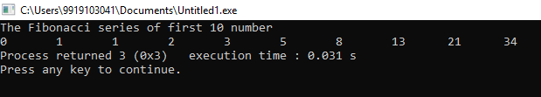

**QUESTION 5**

#include<stdio.h>

#include<conio.h>

int main()

{int i;

for(i=1;i<=20;i++)

{

if(i%2==0)

printf("\nEven\t %d",i);

else

printf("\nOdd\t %d",i);

}

getch();

}

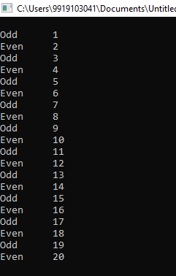

**QUESTION 6**

#include<stdio.h>

#include<conio.h>

int main()

{

int i,n,a=0,b=1,c;

int flag=0;

printf("Enter a no to be searched in fibonacci series:");

scanf("%d",&n);

while(1)

{

c=a+b;

a=b;

b=c;

if(c==n)

{

printf("Fibonacci no");

break;

}

if(c>n)

{

printf("Not a Fibonnaci no");

break;

}

};

getch();

}

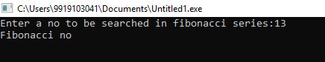

**QUESTION 7**

#include<stdio.h>

#include<conio.h>

int main()

{

int n;

int Add=0;

while(1)

{

printf("Enter a number: \n");

scanf("%d",&n);

if(n>0)

Add+=n;

else

break;

}

printf("Sum is: %d",Add);

getch();

}

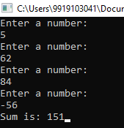

**QUESTION 8**

#include<stdio.h>

#include<conio.h>

int main()

{

int n,r,Sum_Of_Digits=0;

printf("Enter a no\n");

scanf("%d",&n);

while(n>0)

{

r=n%10;

Sum_Of_Digits+=r;

n=n/10;

}

printf("Sum of Digits:%d",Sum_Of_Digits);

getch();

}

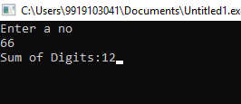

**QUESTION 9**

#include<stdio.h>

#include<conio.h>

int main()

{

int i,n,flag=0;

printf("Enter a no to check for prime number");

scanf("%d",&n);

for(i=2;i*i<=n;i++)

{

if(n%i==0)

{

flag++;

break;

}

}

if(flag!=0)

printf("Non Prime");

else

printf("Prime No");

}

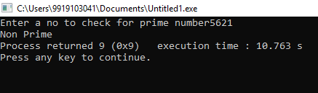

**QUESTION 10**

#include<stdio.h>

#include<conio.h>

int main()

{

int i,j,flag;

printf("Prime no are:");

for(i=2;i<100;i++)

{ flag=0;

for(j=2;j*j<=i;j++)

{

if(i%j==0)

{

flag++;

break;

}

}

if(flag==0)

{

printf("\n%d",i);

}

}

getch();

}

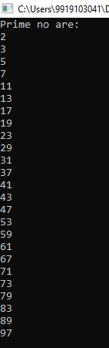

**QUESTION 11**

#include<stdio.h>

#include<conio.h>

int main()

{

int a,b,r=0;

int Lcm,Hcf=0,temp,temp1;

printf("Enter two no to know their HCF and LCM");

scanf("%d \t %d",&a,&b);

temp=a;

temp1=b;

r=a%b;

while(r!=0)

{

a=b;

b=r;

r=a%b;

};

Hcf=b;

printf("HCFis:%d\n",b);

Lcm=(temp*temp1)/Hcf;

printf("LCM:%d",Lcm);

getch();

}

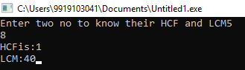

**QUESTION 12**

#include<stdio.h>

#include<conio.h>

int main()

{

int n,rev=0,temp,r=0;

printf("Enter a no\n");

scanf("%d",&n);

temp=n;

while(n>0)

{

r=n%10;

rev=rev+r;

n=n/10;

};

if(temp==rev)

printf("Palindrome number");

else

printf("Not Palindrome");

getch();

}

